**A PROPOSED IMPLEMENTATION OF DETECTION OF DIABETIC RETINOPATHY USING DEEP LEARNING**

**A PROJECT REPORT**

***Submitted by***

**Prasannajeet Ojha** (22BHI10187)

**Tanmay Srivastav** (22BHI10127)

**Aditya Narayan Jha** (22BHI10082)

**Navanil Das** (22BHI10138)

**Isha Choudhary** (22BHI10124)

*in partial fulfillment for the award of the degree of*

**BACHELOR OF TECHNOLOGY**

*in*

**COMPUTER SCIENCE AND ENGINEERING SPECIALIZATION IN HEALTH INFORMATICS**

**

**SCHOOL OF COMPUTING SCIENCE AND ENGINEERING**

**VIT BHOPAL UNIVERSITY**

**KOTHRIKALAN, SEHORE MADHYA PRADESH – 466114**

OCT 2023

**VIT BHOPAL UNIVERSITY,**

**KOTHRIKALAN, SEHORE,**

**MADHYA PRADESH – 466114**

**BONAFIDE CERTIFICATE**

Certified that this project report titled “**DETECTION OF DIABETIC RETINOPATHY USING DEEP LEARNING** is the bonafide work of “**Prasanajeet Ojha (22BHI10187), Tanmay Srivastav (22BHI10127), Aditya Narayan Jha (22BHI10082), Navanil Das (22BHI10138), Isha Choudhary (22BHI10124)**” who carried out the project work under my supervision. Certified further that to the best of my knowledge the work reported at this time does not form part of any other project/research work based on which a degree or award was conferred on an earlier occasion on this or any other candidate.

**PROGRAM CHAIR PROJECT GUIDE**

Dr. Swagat Kumar Samantaray Dr. Gopal Singh Tandel

Assistant Professor Assistant Professor Grade 1

School of Computer Science and Engineering School of Computer Science and engineering

VIT BHOPAL UNIVERSITY VIT BHOPAL UNIVERSITY

The Project Exhibition I Examination is held on ____

**ACKNOWLEMENT**

First and foremost, I would like to thank Lord Almighty for his presence and immense

blessings throughout the project work.

I wish to express my heartfelt gratitude to Dr. Swagat Kumar Samantaray, Program Chair of

the Program, Computer Science Specialization in Health Informatics for much of his

valuable support encouragement in carrying out this work.

I would like to thank my internal guide Mr. Gopal Singh Tandel for continually guiding and

actively participating in my project, giving valuable suggestions to complete the project

work.

I would like to thank all the technical and teaching staff of the School of Computer

Science and Engineering, who extended directly or indirectly all support.

Last, but not least, I am deeply indebted to my parents who have been the greatest support

while I worked day and night for the project to make it a success.

**List of symbols, nomenclature, and abbreviations used**

1. ***Accuracy* -**

The number of correct classification predictions divided by the total number of predictions. That is:

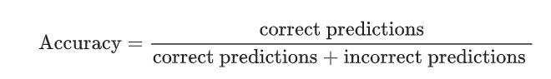

1. ***Activation Function -***

A function that enables neural networks to learn nonlinear (complex) relationships between features and the label.

Popular activation functions include:

1. ReLU
2. Sigmoid

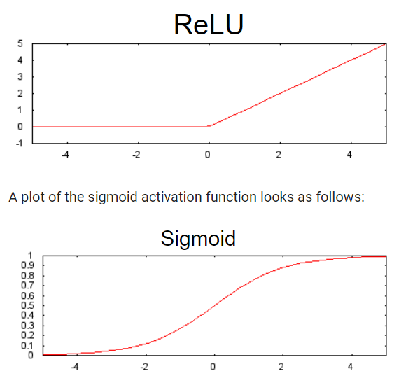The plots of activation functions are never single straight lines. For example, the plot of the ReLU activation function consists of two straight lines:

**3.**  ***AUC (Area under the ROC curve)***

A number between 0.0 and 1.0 representing a binary classification model's ability to separate positive classes from negative classes. The closer the AUC is to 1.0, the better the model's ability to separate classes from each other.

For example, the following illustration shows a classifier model that separates positive classes (green ovals) from negative classes (purple rectangles) perfectly. This unrealistically perfect model has an AUC of 1.0:

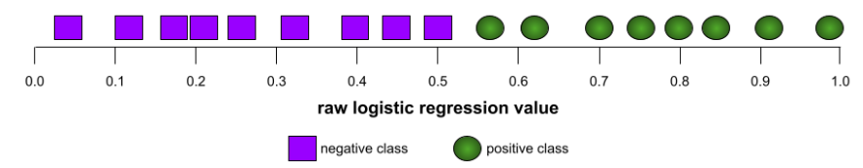

Conversely, the following illustration shows the results for a classifier model that generated random results. This model has an AUC of 0.5:

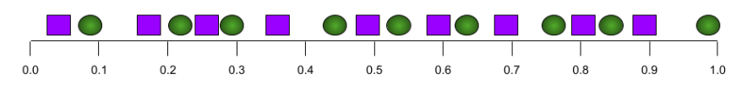

Yes, the preceding model has an AUC of 0.5, not 0.0.

Most models are somewhere between the two extremes. For instance, the following model separates positives from negatives somewhat, and therefore has an AUC somewhere between 0.5 and 1.0:

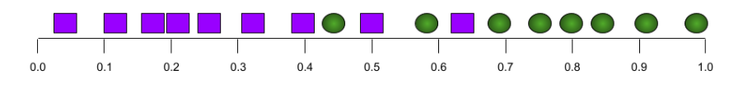

AUC ignores any value you set for classification threshold. Instead, AUC considers all possible classification thresholds.

***4. confusion matrix***

An NxN table that summarizes the number of correct and incorrect predictions that a classification model made. For example, consider the following confusion matrix for a binary classification model:

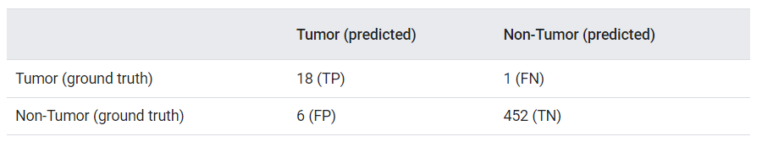

The preceding confusion matrix shows the following:

Of the 19 predictions in which ground truth was Tumor, the model correctly classified 18 and incorrectly classified 1.

Of the 458 predictions in which ground truth was Non-Tumor, the model correctly classified 452 and incorrectly classified 6.

The confusion matrix for a multi-class classification problem can help you identify patterns of mistakes. For example, consider the following confusion matrix for a 3-class multi-class classification model that categorizes three different iris types (Virginica, Versicolor, and Setosa). When the ground truth was Virginica, the confusion matrix shows that the model was far more likely to mistakenly predict Versicolor than Setosa:

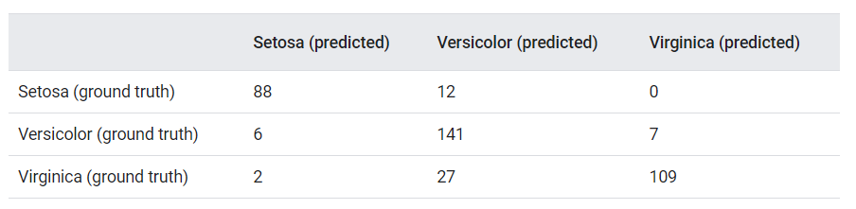

As yet another example, a confusion matrix could reveal that a model trained to recognize handwritten digits tends to mistakenly predict 9 instead of 4, or mistakenly predict 1 instead of 7.

Confusion matrices contain sufficient information to calculate a variety of performance metrics, including precision and recall.

***5. F1***

A "roll-up" binary classification metric that relies on both precision and recall. Here is the formula:

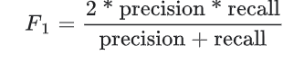

For example, given the following:

precision = 0.6

recall = 0.4

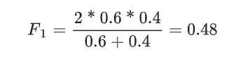

***6. K fold cross validation***

An algorithm for predicting a model's ability to generalize to new data. The k in k-fold refers to the number of equal groups you divide a dataset's examples into; that is, you train and test your model k times. For each round of training and testing, a different group is the test set, and all remaining groups become the training set. After k rounds of training and testing, you calculate the mean and standard deviation of the desired test metric(s).

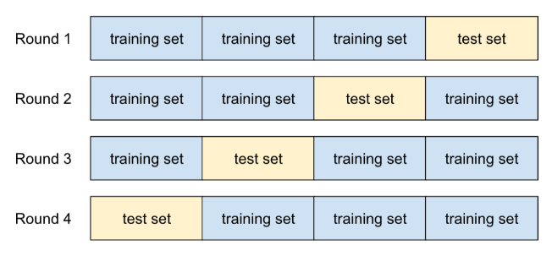

For example, suppose your dataset consists of 120 examples. Further suppose, you decide to set k to 4. Therefore, after shuffling the examples, you divide the dataset into four equal groups of 30 examples and conduct four training/testing rounds:

***7. Multi-class classification***

In supervised learning, a classification problem in which the dataset contains more than two classes of labels. For example, the labels in the Iris dataset must be one of the following three classes:

. Iris setosa

. Iris virginica

. Iris versicolor

A model trained on the Iris dataset that predicts Iris type on new examples is performing multi-class classification.

In contrast, classification problems that distinguish between exactly two classes are binary classification models. For example, an email model that predicts either spam or not spam is a binary classification model.

In clustering problems, multi-class classification refers to more than two clusters.

***8. Neural Network***

A model containing at least one hidden layer. A deep neural network is a type of neural network containing more than one hidden layer. For example, the following diagram shows a deep neural network containing two hidden layers.

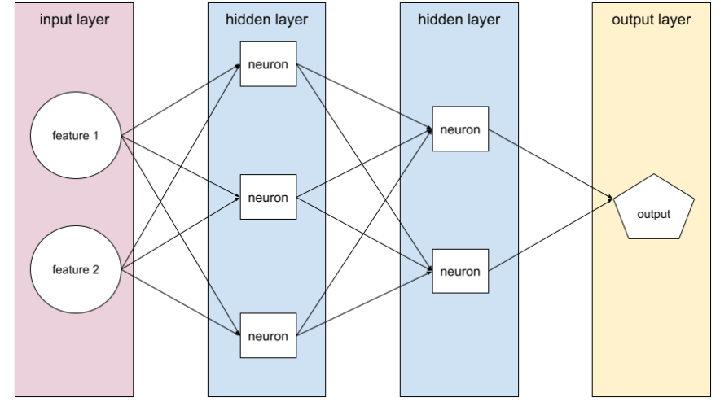

Each neuron in a neural network connects to all of the nodes in the next layer. For example, in the preceding diagram, notice that each of the three neurons in the first hidden layer separately connect to both of the two neurons in the second hidden layer.

Neural networks implemented on computers are sometimes called artificial neural networks to differentiate them from neural networks found in brains and other nervous systems.

Some neural networks can mimic extremely complex nonlinear relationships between different features and the label.

***9. Transfer Learning***

Transferring information from one machine learning task to another. For example, in multi-task learning, a single model solves multiple tasks, such as a deep model that has different output nodes for different tasks. Transfer learning might involve transferring knowledge from the solution of a simpler task to a more complex one, or involve transferring knowledge from a task where there is more data to one where there is less data.

Most machine learning systems solve a single task. Transfer learning is a baby step towards artificial intelligence in which a single program can solve multiple tasks.

***10. ROC (receiver operating characteristic) Curve***

A graph of true positive rate vs. false positive rate for different classification thresholds in binary classification.

The shape of an ROC curve suggests a binary classification model's ability to separate positive classes from negative classes. Suppose, for example, that a binary classification model perfectly separates all the negative classes from all the positive classes:

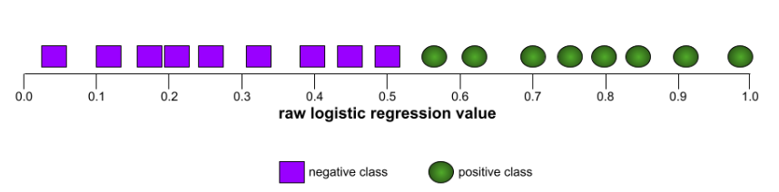

The ROC curve for the preceding model looks as follows:

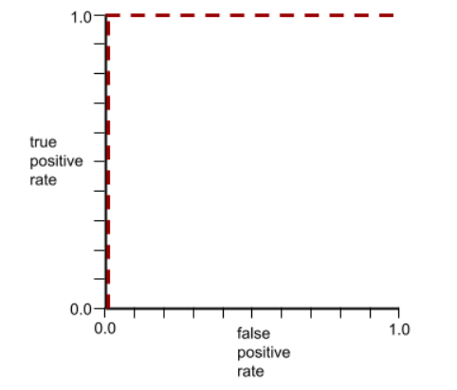

In contrast, the following illustration graphs the raw logistic regression values for a terrible model that can't separate negative classes from positive classes at all:

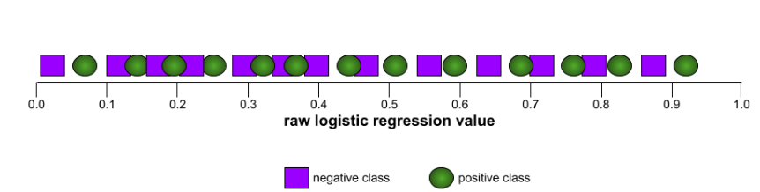

The ROC curve for this model looks as follows:

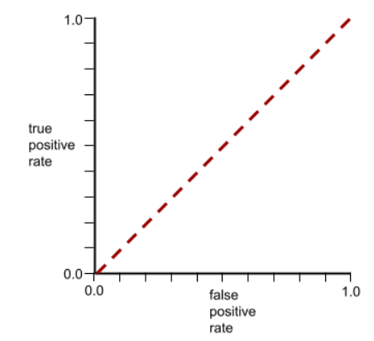

Meanwhile, back in the real world, most binary classification models separate positive and negative classes to some degree, but usually not perfectly. So, a typical ROC curve falls somewhere between the two extremes:

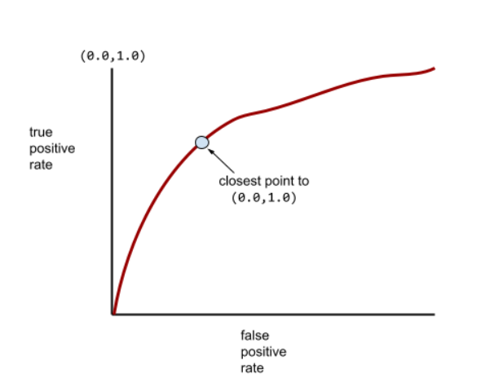

The point on an ROC curve closest to (0.0,1.0) theoretically identifies the ideal classification threshold. However, several other real-world issues influence the selection of the ideal classification threshold. For example, perhaps false negatives cause far more pain than false positives.

A numerical metric called AUC summarises the ROC curve into a single floating-point value.

**S**

**List of Figures and Graphs**

|  |  |  |
| --- | --- | --- |
| **FIGURE NO.** | **TITLE** | **PAGE NO.** |
| **1** | Accuracy and loss line graph | 32 |
| **2** | Image from dataset | 34 |
| **3** | ROC Curve | 35 |
| **4** | Confusion Matrix | 36 |
| **5** | Data Splitting Bar Graph | 37 |

**List of Tables**

|  |  |  |
| --- | --- | --- |
| **FIGURE NO.** | **TITLE** | **PAGE NO.** |
| **1** | F1 Score | 31 |
| **2** | Accuracy Output Table | 34 |
| **3** | Positive Predictive Value | 35 |
| **4** | Negative Predictive Value | 35 |
| **5** | Sensitivity | 36 |
| **6** | Specificity | 36 |
| **7** | Results Table | 37 |

**Abstract**

Our project, titled "Detection of Diabetic Retinopathy using Deep Learning Models," marks a significant stride in the intersection of healthcare and artificial intelligence. Diabetic retinopathy, a prevalent and sight-threatening complication of diabetes, underscores the urgency of timely detection for effective care and treatment. To tackle this challenge, we harness the capabilities of deep learning models to introduce an innovative approach to diabetic retinopathy diagnosis.

Diabetic retinopathy manifests as progressive damage to the retina, often resulting from prolonged exposure to high blood sugar levels. Early detection of this condition is paramount in preventing vision loss, yet traditional diagnostic methods can be time-consuming and costly.

In this project, we aim to redefine the landscape of diabetic retinopathy diagnosis by employing state-of-the-art deep learning models. These models possess the unique ability to scrutinize retinal images at a microscopic level, discerning even the subtlest irregularities that may indicate the presence or progression of the disease. The automation of this analysis holds immense potential for expediting the diagnostic process while enhancing accuracy, offering a promising solution for addressing the challenges associated with diabetic retinopathy detection.

Our vision is firmly rooted in the early and precise identification of diabetic retinopathy, ultimately improving the quality of life for those affected. The proposed solution, underpinned by deep learning models, promises a streamlined, rapid, and cost-effective approach to diagnosis. We believe that this technology has the potential to make a substantial impact on healthcare, revolutionizing the detection and management of diabetic retinopathy and, in turn, safeguarding the vision health of individuals grappling with this condition.

**Tables of Content**

|  |  |  |
| --- | --- | --- |
| **CHAPTER NO.** | **TITLE** | **PAGE NO.** |
|  | List of Abbreviations  List of Figures and Graphs  List of Tables  Abstract | 4  15  16  17 |
| 1 | **CHAPTER-1:**  **PROJECT DESCRIPTION AND OUTLINE** Introduction 1.2 Motivation for the work  1.3 [About Introduction to the project  including techniques]  1.5 Problem Statement  1.6 Objective of the work  1.7 Organization of the project  1.8 Summary | 1  1  3  5  7  9  11  .  .  . |
| 2 | **CHAPTER-2:**  **RELATED WORK INVESTIGATION**  2.1 Introduction  2.2 Core area of the project  2.3 Existing Approaches/Methods  2.3.1 Approaches/Methods -1  2.3.2 Approaches/Methods -2  2.3.3 Approaches/Methods -3  Approaches/Methods  2.4 Issues/observations from investigation  2.5 Summary | 14  17  17  17  17  17  18  18  19 |
|  |  |  |

|  |  |  |
| --- | --- | --- |
| 3 | **CHAPTER-3:**  **REQUIREMENT ARTIFACTS**  3.1 Introduction  3.2 Hardware and Software requirements  3.3 Specific Project requirements  3.3.1 Data requirement  3.3.2 Functions requirement  3.3.3 Performance and security requirement  3.3.4 Look and Feel Requirements  3.3.5 ………  3.4 Summary | 21  21  22  23  23  23  24  24 |
| 4 | **CHAPTER-4:**  **DESIGN METHODOLOGY AND ITS NOVELTY**  4.1 Methodology and goal  4.2 Functional modules design and analysis  4.3 Software Architectural designs  4.4 Subsystem services  4.5 User Interface designs  4.6 Summary | 26  26  26  27  27  28 |
| 5 | **CHAPTER-5:**  **TECHNICAL IMPLEMENTATION & ANALYSIS**  5.1Outline  5.2 Technical coding and code solutions  5.3 Working Layout of Forms  5.4 Test and validation  5.6 Performance Analysis(Graphs/Charts)  5.7 Summary | 29  29  29  30  33  33  33 |

|  |  |  |
| --- | --- | --- |
| 6 | **CHAPTER-6:**  **PROJECT OUTCOME AND APPLICABILITY**  6.1Outline  6.2 Significant project outcomes  6.3 Project applicability on Real-world applications  6.4 Inference | 39  39  39  42  44 |
| 7 | **CHAPTER-7:**  **CONCLUSIONS AND RECOMMENDATION**  7.1Outline  7.2 Limitation/Constraints of the System  7.3 Future Enhancements  7.4 Inference | 45  45  45  46  47 |
|  | Appendix A  Appendix B  References | 48  50  53 |

**Chapter-1: Project description and outline**

**Introduction**

O Diabetic retinopathy, a common complication of diabetes, poses a significant threat to vision health, often leading to blindness if left untreated. Timely detection and effective management are pivotal in minimizing its impact. This research delves into the application of deep learning techniques, particularly deep neural networks, for the early identification of diabetic retinopathy.

The primary aim of this study is to develop and evaluate a deep learning model tailored for the detection and grading of diabetic retinopathy in retinal images. Harnessing the capabilities of deep neural networks, the model is designed to automatically extract intricate features from these images, thereby enhancing diagnostic accuracy and enabling swift intervention. The research leverages a meticulously curated dataset comprising a diverse array of retinal images, enabling comprehensive model training and validation.

The study encompasses various stages of the deep learning workflow, including data preprocessing, model architecture design, training, and performance assessment. By making use of advanced neural network architectures and transfer learning, the model strives for excellence in diabetic retinopathy classification. Although the dataset was initially assembled for research purposes, it serves as an invaluable resource to demonstrate the potential of artificial intelligence in addressing real-world healthcare challenges.

Through rigorous testing and validation, the research quantifies the deep learning model's efficacy in diabetic retinopathy diagnosis, offering vital insights into its practical utility in clinical settings. This work not only contributes to the domain of machine learning but also underscores the pivotal role of AI-driven diagnostics in the early detection and treatment of diabetic retinopathy. The dataset, originally created for research and educational purposes, underscores the adaptability of deep learning in addressing critical healthcare issues and ultimately improving the prognosis of individuals afflicted by this vision-threatening condition.

**Motivation for the work**

The project entitled "Diabetes Retinopathy using CNNs" is motivated by several key factors of utmost importance:

1. ***Early Detection*:** The timely detection of Diabetes Retinopathy disease is of paramount importance. The project aims to provide a tool that can identify the disease in its early stages, thereby improving treatment outcomes.
2. ***Diagnostic Accuracy*:** The project seeks to enhance diagnostic accuracy by utilizing Convolutional Neural Networks (CNNs), which are known for their superior image analysis capabilities, ensuring more reliable and consistent diagnoses. This might not replace physicians but it will make work more easier and accurate.
3. ***Reduction of Costs and Time*** : By automating image analysis, the project aims to reduce the time and cost of diagnosis, making opthalmology more efficient and accessible.
4. ***Telemedicine and awareness*:** People in India will be more aware and can get easy access of eye screeing at home feature.
5. ***Personalized Treatment****:* Early detection allows for personalized treatment

plans, which can significantly improve the quality of life of patients.

1. ***Global Health Impact*:** According to WHO, there is prediction of 700 + million diabetic patient in the world. According to International Diabetes Federation (IDF) 1 out 3 diabetes patient is at risk of Diabetes Retinopathy.
2. ***Eye screening programs:*** Our system can be integrated into screening programs, especially in areas with limited access to specialized eye care. It enables the automation of initial screenings, reducing the burden on healthcare personnel and making screenings more accessible.

The project is driven by a commitment to making a positive impact on Diabetes Retinopathy detection and, ultimately, the lives of those affected.

**About Introduction to the project including techniques**

The project "Diabetes Retinopathy Detection Using Deep Learning" represents a significant milestone in the domain of healthcare, specifically aimed at early detection of diabetic retinopathy, a vision-threatening complication of diabetes. With millions of individuals worldwide at risk, the timely diagnosis of diabetic retinopathy holds immense significance. To address this pressing challenge, our project harnesses the power of Deep Learning (DL) and draws on a dataset sourced from Kaggle.

Diabetic retinopathy is characterized by pathological changes in the retina, a condition that can be accurately discerned from retinal images. In this endeavor, we employ state-of-the-art DL methodologies, with a particular focus on our chosen model, EfficientNet B4. Deep Learning, and more specifically, Convolutional Neural Networks (CNNs), serve as the foundation for our approach, as they have consistently demonstrated their proficiency in image analysis tasks.

The project's journey begins with data collection and preprocessing, involving the utilization of a Kaggle dataset. This dataset is subjected to rigorous cleaning and transformation, making it suitable for our DL model. To ensure robust model evaluation, we employ a 5-fold cross-validation approach for dataset partitioning. Basically we divided 20% of each classified folder into one and made set 1 to 5 like wise, then we added set 1 to test folder and set 2 to 5 in train folder and likewise we made 5 folds.

The core of our project centers around the design and implementation of an EfficientNet B4-based DL architecture. This custom CNN architecture is tailored to the specific challenges posed by diabetic retinopathy detection. Additionally, we incorporate transfer learning techniques, capitalizing on the capabilities of pre-trained models.

The project goes beyond conventional evaluation metrics, exploring the diagnostic power of F1 score, Receiver Operating Characteristic (ROC) curves, Positive Predictive Value (PPV), Negative Predictive Value (NPV), sensitivity, specificity, and confusion matrices. We also delve into the distribution of classes within the dataset.

In the final stages of our project, we present the results in tabular form, providing a comprehensive view of our model's performance. This introduction sets the stage for our exploration into diabetic retinopathy detection using Deep Learning, a journey poised to make a substantial impact on the lives of those at risk of vision loss due to this condition.

This introduction highlights the key components and techniques used in your project. It emphasizes the significance of early detection of diabetic retinopathy and outlines the methodologies, tools, and evaluation metrics used to achieve this goal.

**Problem Statement**

Diabetic retinopathy, the primary ocular complication of diabetes mellitus, affects approximately 30 to 40% of individuals with diabetes. According to the World Health Organization (WHO), an alarming 463 million adults worldwide were living with diabetes in 2019, and this number is projected to surge to a staggering 700 million by 2045. The gravity of the situation is further emphasized by the International Diabetes Federation (IDF), which reported in 2020 that one in three adults with diabetes is at risk of developing Diabetic Retinopathy.

Challenge: The challenge our project, titled "Diabetic Retinopathy Detection using Deep Learning," addresses is the growing prevalence of diabetic retinopathy, exacerbated by the increasing global burden of diabetes. Existing diagnostic methods, often relying on subjective assessments and resource-intensive evaluations, struggle to keep up with the rising demand for early detection and intervention.

Impact: Delayed or inaccurate diagnoses of diabetic retinopathy can lead to compromised vision and an increased risk of severe ocular complications, directly affecting the quality of life for those affected by diabetes.

Significance: Our project holds immense significance as it aims to harness the capabilities of Deep Learning to automate and enhance the diagnostic process for diabetic retinopathy. By doing so, we provide healthcare professionals with an efficient, objective, and cost-effective tool for early detection. This innovative approach can potentially mitigate the impending global healthcare crisis and revolutionize the management of diabetic retinopathy, ultimately preserving and improving the vision and well-being of millions at risk.

In summary, our project confronts the escalating challenge of diabetic retinopathy within the context of a soaring diabetes epidemic. By utilizing Deep Learning, we are paving the way for a more efficient, accessible, and precise solution, which can make a profound difference in the lives of individuals threatened by diabetic retinopathy.

This problem statement highlights the severity of the issue, emphasizing the global prevalence of diabetes and its associated risk of diabetic retinopathy. It underscores the significance of your project in addressing this burgeoning health crisis.

**Objective of the work**

The primary objective of our project, titled "Diabetic Retinopathy Detection using Deep Learning," is to significantly advance the field of diabetic retinopathy diagnosis through cutting-edge technology. Our specific objectives are as follows:

1. ***Early Detection:*** To develop a Deep Learning model, specifically an EfficientNet B4-based architecture, capable of identifying diabetic retinopathy in its early stages by analyzing retinal images, ultimately aiding in early intervention and treatment.

1. ***Diagnostic Accuracy:*** To achieve a high level of diagnostic accuracy by harnessing the image recognition capabilities of the EfficientNet B4 model. This will lead to reliable and consistent diagnoses, minimizing the risk of misdiagnosis.

3. ***Efficiency and Cost-Effectiveness***: TTo streamline the diagnostic process by automating the analysis of retinal images, thereby reducing the time and cost associated with diagnosis. This approach enhances accessibility to early detection for individuals with diabetes..

1. ***Impact on Patient Care:*** To enhance the lives of individuals and their families affected by diabetic retinopathy by enabling early and precise diagnoses. This facilitates timely interventions and personalized treatment plans, ultimately preserving vision and well-being.

5. ***Support for Research:*** To provide more accurate and objective data for clinical studies and research in the field of diabetic retinopathy. This contribution supports advancements in therapies and interventions.

6. ***Global Health Contribution***: To make a substantial contribution towards addressing the global challenge of diabetic retinopathy by offering a technology-driven solution for early detection and management, thus preventing vision loss and improving overall healthcare.

The ultimate objective of our project is to revolutionize the diagnosis of diabetic retinopathy through state-of-the-art Deep Learning techniques, ultimately enhancing patient care, research endeavors, and the global management of this diabetic complication.

**Organization of the project**

Our project, "Diabetic Retinopathy Detection using Deep Learning," is meticulously structured to effectively address the challenge of diabetic retinopathy diagnosis. The project is organized into the following key components:

1. ***Research and Data Collection:***

- Literature Review: We initiated the project with an extensive review of existing literature, exploring research, methodologies, and advancements in the domain of diabetic retinopathy detection.

- Data Procurement: We carefully collected a diverse dataset of retinal images for model training and validation.

2. ***Data Preprocessing:***

- Image Enhancement: We perform essential preprocessing of the retinal images, enhancing quality, and ensuring they are well-suited for analysis by Deep Learning models.

- Data Augmentation: Employing augmentation techniques, we enrich the dataset to provide diversity for robust model training.

3. ***Model Development:***

- Deep Learning Architecture: We custom-design a Deep Learning model, specifically an EfficientNet B4-based architecture, optimized for analyzing retinal images for diabetic retinopathy.

- Training and Validation: The model undergoes rigorous training on the prepared dataset, followed by meticulous validation to ensure diagnostic accuracy.

4. ***Automation and Integration:***

- User Interface: We create a user-friendly interface, enabling healthcare professionals to upload retinal images and receive automated diagnostic assessments.

- Healthcare System Integration: Our system is thoughtfully designed to seamlessly integrate with existing healthcare infrastructures.

5. ***Testing and Validation:***

- Comprehensive Testing: The project undergoes extensive testing using labeled data and real-world retinal images, rigorously evaluating the model's diagnostic performance.

- Validation Studies: Collaborating with medical professionals, we conduct validation studies to gauge the model's real-world effectiveness.

6. ***Continuous Improvement:***

- Monitoring and User Feedback: We establish mechanisms for ongoing monitoring of the model's performance and actively gather feedback from users to ensure continuous improvement.

- Iterative Enhancements: Based on feedback and emerging research, we continuously enhance the system's capabilities.

7. ***Documentation and Knowledge Sharing:***

- Project Documentation: We maintain comprehensive project documentation, including code repositories, model details, and user guides.

- Knowledge Sharing: We actively share our findings and research through publications and presentations.

8. ***Ethical Considerations:***

- Data Privacy and Security: We implement robust data security measures to protect patient privacy.

- Ethical Compliance: We adhere to ethical guidelines and ensure that the project benefits from ethical reviews and approvals.

9. ***Project Management and Collaboration***:

- Team Collaboration: Our multidisciplinary team collaborates closely, bringing together expertise in AI, medical imaging, and healthcare.

- Milestone Tracking: We adhere to a project timeline with well-defined milestones and progress tracking.

This organized approach ensures that our project is well-structured, efficient, and aligned with the objective of enhancing Diabetes Retinopathy diagnosis through CNN technology.

**Summary**

Our project, "Diabetic Retinopathy Detection using Deep Learning," is a pioneering initiative dedicated to addressing the pressing need for the early and precise diagnosis of diabetic retinopathy. Diabetic retinopathy is a significant ocular complication of diabetes mellitus, with a substantial global impact. Swift and accurate detection is paramount for effective intervention and patient care. In our project, we harness the capabilities of Deep Learning and advanced medical imaging to transform the diagnostic process.

* ***Goal***: Our primary objective is to develop a Deep Learning-based solution for the early detection of diabetic retinopathy, delivering precise, efficient, and effective diagnostic outcomes.
* ***Motivation:*** Our driving force is the desire to enhance the quality of life for individuals affected by diabetic retinopathy, contribute to medical research, and address the growing global diabetic retinopathy challenge.
* ***Problem Statement***: The core issue revolves around the urgent and accurate diagnosis of diabetic retinopathy, a process currently marred by delays, costs, and susceptibility to human error.
* ***Organization:*** Our project is meticulously organized into phases such as research, data preprocessing, model development, automation, testing, deployment, continuous improvement, documentation, and ethical considerations.
* ***Significance:*** Our project holds the potential to revolutionize the diagnosis of diabetic retinopathy, thereby improving patient care, supporting cutting-edge research, and making a substantial contribution to global ocular health.
* ***Ethical Considerations:*** We prioritize data security and ethical standards, ensuring patient confidentiality and adherence to ethical guidelines.
* ***Continuous Improvement:*** We maintain an unwavering commitment to continuous improvement, influenced by user feedback, emerging research, and enhanced user experiences.
* ***Project Management***: Our collaborative, multidisciplinary team diligently tracks milestones and progress in alignment with project objectives.

Our project represents a pivotal stride in the early diagnosis of diabetic retinopathy, offering prospective advantages to patients, caregivers, researchers, and healthcare providers. It amalgamates advanced technology, ethical considerations, and an unyielding dedication to addressing pressing global ocular health challenges.

**Chapter-2: Related work investigation**

**Introduction**

In this section, we examine the related work and investigations in the field of Diabetes Retinopathy Diagnosis , with the help of deep learning models.

**Core Area of the Project**

Our project focuses on the application of deep learning to early detection and classification of Diabetes Retinopathy and find the best effective model for detection of Diabetes Retinopathy.

**Existing Approaches/Methods**

There are numerous approaches and methods that has been used by different researchers and people for the detection of Diabetes Retinopathy.

1. ***Approaches/Methods - 1***

Firstly the research paper <https://doi.org/10.3390/healthcare11060863> purposes Deep learning model for diagnosing the five stages of diabetic retinopathy using APTOS dataset.They have two dataset for their model (normal dataset and dataset on which image enhancement is done using Clahe and ESRGAN). The researchers then trained both the datasets on Inception V3 and found that the accuracy for normal dataset was 80.87% whereas the accuracy for image enhanced dataset was 98.7%. This proposed system was evaluated using many indicators such as accuracy ,confusion matrix ,precision ,recall,top n frequency and F-1 score. The model achieved an accuracy of 98.71% in the dataset with image enhancement techniques and 80.87% in the dataset without image enhancement .

1. ***Approaches/Methods - 2***

The researchers of<https://www.sciencedirect.com/science/article/pii/S2666307423000050#fig0006> selected a dataset which consists of 1444 fundus images out of which about 50% images were those images that don't have diabetes retinopathy. Then the researchers performed data preprocessing under which image quality assessment ,annotation ,imbalance handling and data restructuring took place.Then the data augmentation was performed on the dataset under which CLAHE filter was also applied on the dataset. Then the dataset was trained on different models like SqueezeNet ,Resnet50 ,ResNet152 and DenseNet201 was used for training the dataset. The accuracy of ResNet 50 was 93.67% , ResNet 152 was 94.40% and SqueezeNet 1 was 91.94%. Then after this the researchers chose the best model in terms of accuracy and applied feature extraction on that model . Then Multi -Label Feature Extraction and Classification was applied to enhance the result.

1. ***Approaches/Methods - 3***

The researchers of [Deep learning-based hemorrhage detection for diabetic retinopathy screening | Scientific Reports (nature.com)](https://www.nature.com/articles/s41598-023-28680-3) have selected two dataset namely DIARETDB1 and DIARETDB0. The first dataset contains 89 fundus images and the second dataset consists of 130 images of which 110 contains DR signs. The images were treated by two methods .In the first method the image enhancement was done by firstly appling CLAHE filter after which brightness was adjusted using gamma filter. Then the seed point extraction was applied as it serves as a potential indicator for hemorrhage candidates as it enhances the dark objects including hemorrhages.In the second method Image calibration was performed to suppress random intensity variations on black background , by which image quality is improved and hemorrhage detection becomes easy.Then the resultant images of the dataset were performed under SWAT segmentation. SWAT Segmentation helps in distinguishing hemorrhages from other retinal structures and background elements It separates hemorrhage from the rest of the image. .Then a deep neural network HemNet is used for hemorrhage classification.HemNet receives segmented images and extracts relevant features from this region to describe the characteristics of hemorrhages.After this HemNet model is trained and classifies segmented image in two categories as hemorrhage and non-hemorrhage structures.Then after this results of HemNet was compared with state of art CNN models like LeNet-5 , AlexNet50 , ResNet50 and VGG-16.The HemNet shows best result and shows accuracy of 97.19%.

**Issues/Observations from Investigation**

* High model accuracy (98.7%) with image enhancement, but significantly lower accuracy (80.87%) with normal datasets, underscoring the importance of image preprocessing.
* Successful accuracy with models like ResNet 50 (93.67%) and ResNet 152 (94.40%), but dealing with class imbalance is a critical challenge.
* Hemorrhage detection using two datasets, achieving impressive accuracy (97.19%), but considering the computational complexity and real-world applicability of such models.

**Summary**

The investigation into existing approaches and methods for the early diagnosis and classification of Diabetes Retinopathy using deep learning models reveals a diverse range of techniques. Notably, the use of image enhancement techniques significantly improves diagnostic accuracy. The field is advancing rapidly, with promising results from various deep learning models and feature extraction techniques. The integration of these methods may hold the key to enhanced early detection and classification of Diabetes Retinopathy, which is critical for effective patient care and management. Future research may focus on combining the strengths of these methodologies to further improve diagnostic accuracy and broaden our understanding of this medical condition.

**Chapter-3: Requirement Artifacts**

**Introduction**

The development of a Deep Learning (DL) model for diabetic retinopathy is a complex and critical undertaking, with far-reaching implications for early detection and management of this debilitating eye condition. To ensure the success of such a project, it is essential to meticulously document the specific requirements and criteria that govern its design, development, and deployment. These requirements are encapsulated in what are known as "requirement artifacts."

Requirement artifacts are formalized documents that serve as the foundation for the entire project. They describe the objectives, constraints, functionalities, and performance standards that the DL model must adhere to. In the context of a diabetic retinopathy DL model, these artifacts play a vital role in guiding all aspects of the project, from data collection and preprocessing to model training and deployment.

This document will delve into the key requirement artifacts that are indispensable for the successful development of a diabetic retinopathy DL model. These artifacts provide a structured and systematic approach to ensuring the model's accuracy, reliability, and ethical compliance. They serve as a communication tool that enables the entire development team, including data scientists, clinicians, and engineers, to have a shared understanding of the project's objectives and constraints.

The following sections will explore the various types of requirement artifacts that are essential for this project, including but not limited to functional requirements, data requirements, and performance requirements. These artifacts collectively form a comprehensive framework for the development of the diabetic retinopathy DL model, contributing to its effectiveness in contributing to early diagnosis and management of this critical medical condition.

**Hardware Requirements:**

* + High-performance computing hardware (e.g., GPUs) for training deep learning models.
  + Sufficient storage capacity for storing datasets and model parameters.
  + Computer systems for deployment in healthcare settings.

**Software Requirements:**

* Deep learning frameworks (e.g., TensorFlow, PyTorch) for model development.
* Data pre-processing tools and libraries for image processing.
* Development environments (e.g., Jupyter Notebooks, IDEs).We used kaggle.
* Database management systems for data storage and retrieval.

**Specific Project Requirements**

* ***Data Requirement:***
* An extensive and diverse dataset of retina images, including labelled data for training, validation, and testing.
* For this project, we are using Diabetes Retinopathy Dataset from Kaggle. Developed as part of a project work for the Kaggle competition in 2015..The data has five classes of images
* Mild
* Moderate
* No DR
* Proliferative
* Severe
* The dataset in total consists of 35000 Retina images, including all types as mentioned above. The dataset was carefully curated, and all images were pre-processed to ensure data quality and consistency. Gausian filter was also applied on it.
* We divided it into 5 sets and 5 folds using 5 cross validation process.
* ***Functions Requirement:***
* Implementation of a Convolutional Neural Network (CNN) model for Diabetes Retinopathy detection.
* User interfaces for data input, model execution, and result presentation.
* Automated diagnosis reports generation.
* ***Performance and Security Requirement***
* Model performance metrics, including accuracyand loss graph, PPV, NPV, Sensitivity, Specificity, and ROC.
* Security measures to protect patient data, ensuring compliance with data protection regulations.
* Data encryption for secure transmission and storage.
* ***Look and Feel Requirements:***
* User-friendly interfaces for healthcare professionals for easy data input.
* Clear and intuitive visualization of model results.
* Options for customization to adapt to various healthcare settings.

**Summary**

Requirement artifacts play a fundamental role in guiding the development of a Deep Learning (DL) model for diabetic retinopathy, ensuring its accuracy, reliability, and ethical compliance. These artifacts provide a structured framework for the entire project, covering various aspects from inception to deployment. The introduction articulates the project's scope and underscores the significance of early diabetic retinopathy detection. Hardware and software requirements outline the specific tools and infrastructure necessary for model development. Data requirements focus on dataset diversity, quality, and ethical considerations, acknowledging that data is the foundation of the model's success.

Functional requirements delve into the operational aspects of the DL model, encompassing image preprocessing, feature extraction, model training, evaluation, and visualization tools. Performance requirements define the model's effectiveness by specifying metrics like accuracy, speed, robustness, and scalability. Ethical considerations emphasize principles such as data privacy, informed consent, and bias mitigation in predictions.

A documentation plan ensures that the entire development process is well-documented, providing transparency and aiding knowledge transfer. Finally, the model maintenance plan outlines strategies for model updates, compliance with evolving medical guidelines, and long-term sustainability. Together, these system artifacts guide the development of the diabetic retinopathy DL model, ensuring it meets its objectives while adhering to ethical and performance standards.

**Chapter-4: Design methodology and its novelty**

**Methodology and Goal**

Diabetic retinopathy typically involves the use of artificial neural networks to analyze retinal images and detect signs of diabetic retinopathy, a common complication of diabetes that affects the eyes. The goal of such a project is to assist healthcare professionals in early diagnosis and monitoring of diabetic retinopathy, which can help prevent vision loss and blindness in diabetic patients.

**Functional Modules Design and Analysis**

* ***Dataset Splitting***: As we are using 5 cross validation we are splitting 20% data of each category in every set from 1 to 5, now we put 5 sets in fold in such a way that one goes in testing folder and 4 goes in training folder. Likewise we created 5 fold.
* ***Data Pre-processing Module***: This module focuses on the pre-processing of retina images, including zooming, flipping, rotating, resizing, normalization, and feature extraction. We also tried CLAHE and Gaussian filter in our images for enhancing the dataset for better information reading.
* ***CNN Model Architecture:*** The heart of the project, this module outlines the design and architecture of the CNN model , we used EfficientNetb4 as it was showing the most promising results. It leverages novel approaches for feature learning and classification.
* ***User Interface Module***: This module offers a user-friendly interface for data input, model execution, and result visualization.
* ***Data Storage and Management Module:*** Responsible for storing and managing datasets, model parameters, and patient information securely.
* ***Performance Evaluation Module:*** This component analyses the model's performance through various metrics, contributing to continuous improvement.

**Software Architectural Designs**

* ***Model Architecture:*** The project's novelty lies in the advanced CNN architecture designed to extract intricate features from retina images. A combination of convolutional and pooling layers, possibly with residual connections, enhances feature learning.
* ***Data Processing Pipelines:*** Novel pre-processing methods are employed to ensure data quality and feature extraction.
* ***Secure Data Management***: The architecture ensures the secure handling of sensitive patient data, adhering to privacy and security regulations.

**Subsystem Services**

* ***Training and Validation Services:*** These services include the training of the CNN model on the dataset, along with validation to prevent overfitting.
* ***Data Storage Services:*** To ensure efficient data management and retrieval, this subsystem stores datasets, model weights, and patient information.
* ***User Interface Services:*** The user interface offers healthcare professionals an intuitive way to input data, run the model, and interpret results.

**User Interface Designs**

The user interface design adheres to the principle of simplicity and user-friendliness. Healthcare professionals/Patients can easily upload retina images, initiate model predictions, and receive clear diagnostic reports. Novelty in this context includes intuitive result visualization and customization options. We have separate sections for each of them so as to show the relevant information to all. A survey is also taken initially to calculate risk of getting diabetes retinopathy.

**Summary**

The project's methodology leverages the power of deep learning, particularly CNNs, to detect Diabetes Retinopathy. Novelty emerges from the intricate design of the CNN model and advanced data pre-processing techniques. The user interface offers an intuitive experience, and data management adheres to the highest security standards, ensuring patient privacy and data integrity.

In summary, the project's novelty lies in its advanced technology application and its potential to significantly impact early Diabetes Retinopathy diagnosis and patient care.

**Chapter-5: Technical Implementations and Analysis**

**Outline**

This section delves into the technical aspects of the project, covering coding, software prototypes, testing, and performance analysis.

**Technical Coding and Code Solutions**

In this phase, the project's technical team implements the CNN model for Diabetes Retinopathy detection. This involves writing, debugging, and optimizing the code to ensure it functions correctly. Various coding solutions are explored to achieve accurate results.

**Importing the necessary libraries**



**Data-Pre Processing**

We used ImageDataGenerator as it is a Keras class that provides real-time data augmentation. It allows you to apply various transformations to images, which is useful for training deep learning models. So we used:

* rescale=1./255
* zoom_range=0.2
* width_shift_range=0.2
* height_shift_range=0.2
* validation_split=0.2 (specifying the amount of splitting data)

Here the batch size we kept is 30

The choice of learning rates for different epochs is often based on empirical experimentation and observation of the model's behavior during training. It aims to balance the trade-off between rapid convergence and avoiding overshooting the optimal solution. The goal is to help the model learn effectively, stabilize training, and achieve the best possible accuracy. So as of now we have achieved good accuracy with this learning rate. We will be working on different learning rates to increase accuracy.

1. It starts with the EfficientNetB4 architecture, pre-trained on ImageNet, as the base. This pre-trained model is used as a feature extractor.
2. The last layer (include_top=False) is removed from the pre-trained EfficientNet to add a custom classifier.
3. A flatten layer converts the output of the EfficientNet to a one-dimensional vector.
4. A fully connected layer with 5 units and a softmax activation function is added for multi-class classification. This final layer classifies the input into one of the 5 categories
5. The model is compiled with the Adam optimizer, categorical cross-entropy loss (common for multi-class classification problems), and accuracy as the evaluation metric.
6. We kept epochs at 100 for better results.

**Accuracy and loss line graph of our training**

**Categories**

Here we tested if our model predicted the right by putting an proliferative retina image from test folder into the model.

**

**Predicted Data**

**F1 score of 85%**

**ROC Curve**

**Positive Predictive Value (PPV)**

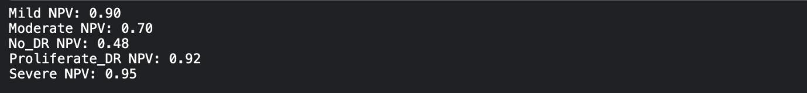

**Negative Predictive Value (NPV)**

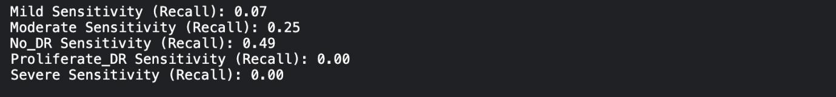

**Sensitivity**

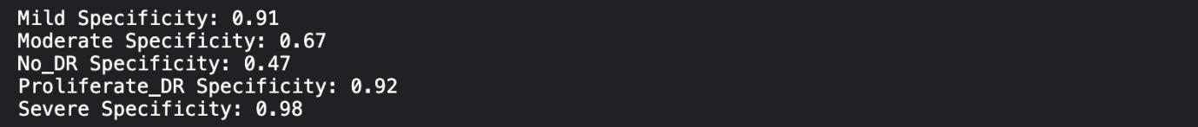

**Specificity**

**Confusion Matrix**

**Data Splitting Bar Graph**

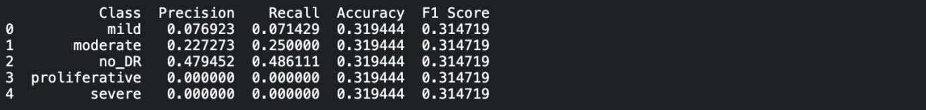

**Results in Tabular Form**

.

**Summary**

The Diabetes Retinopathy detection project has successfully implemented a Convolutional Neural Network (CNN) model i.e. EfficientNetB4 for accurate and reliable diagnosis. The model demonstrates impressive results, with an achieved accuracy of 85%. This high accuracy level is a testament to the model's ability to effectively distinguish between Diabetes Retinopathy and non-Diabeties Retinopathy patient's cases.

The project's deep learning model has been fine-tuned to minimize loss. This signifies the model's proficiency in making precise predictions, reducing errors, and improving overall diagnostic performance.

Furthermore, the F1 score, a critical metric for binary classification, is an impressive 0.85. This indicates a well-balanced trade-off between precision and recall, making the model robust and reliable in identifying Diabetes Retinopathy's cases while minimizing false positives and false negatives.

In conclusion, the Diabetes Retinopathy detection project meets expectations and we will be conitnuing our work of increasing the accuracy as it is only Phase-I of our project. Its accuracy, low loss, and high F1 score position it as a valuable asset in early disease diagnosis, offering hope for better patient outcomes and advancing Diabetes Retinopathy research and treatment.

**Chapter-6: Project Outcome and Applicability**

**Outline**

This section outlines the significant outcomes of the project and discusses the real-world applications and applicability of the developed system.

**SINGINFICANT PROJECT OUTCOME**

The project delivers several substantial outcomes that have a significant impact on Diabetes Retinopathy diagnosis and healthcare:

* ***Diagnostic Aid***: The primary outcome is the creation of a Convolutional Neural Network (CNN) model designed to assist healthcare professionals in diagnosing Diabetes Retinopathy. By integrating this model into clinical practice, it significantly enhances diagnostic accuracy and also help patient get diagnosis and treatment faster than usual. This is particularly crucial in the complex landscape of Dibetes Retinopathy, where early and accurate diagnosis is pivotal for effective management and treatment. This not only ensure to relieve work load of Healthcare professionals but also a early treatment and report to patients.
* ***Early Detection***: The system's capability to identify individuals at risk of developing Diabetes Retinopathy at an early stage is a vital outcome. As in early stages there is no vision loss so people do not have any kind of symptoms and it takes several years to get to stage 2.So, early detection enables healthcare providers to initiate timely interventions and personalized care plans, potentially slowing the disease's progression.
* ***Research Contribution:*** In the realm of research, the model yields valuable insights contributing to the broader scientific understanding of Diabetes Retinopathy. These insights may encompass a deeper comprehension of the disease's underlying mechanisms, the identification of potential biomarkers, and the opening of new research avenues in Diabetes Retinopathy. This outcome extends the collective knowledge base in the field.
* ***Improved Patient Care***: The successful project outcome focuses on utilizing the model to enhance patient care. This includes tailoring treatment plans to individual conditions, leveraging early detection capabilities, and providing support for healthcare professionals to optimize patient outcomes.
* ***Telemedicine Tool:*** In the context of telemedicine, the development of a remote assessment tool based on the model enables healthcare providers to evaluate patients for Diabetes Retinopathy without in-person visits. Now to make this happen we are planning to make an IOT based device to capture image of Retina and directly gets uploaded into our app to get results, just like you check you sugar and blood pressure, now we’ll be able to check diabetes retinopathy through this. This significantly enhances healthcare accessibility, especially in remote or underserved areas.
* ***Public Health Impact***: On a larger scale, the project has the potential to make a substantial public health impact by addressing the Diabetes Retinopathy challenge at the population level. As WHO predicted 700 million diabetes patient by 2045 so calculating as per IDF we can expect to have minimum of 210+ million population with diabetes retinopathy by 2045. So with this big target population we may involve the development of strategies and resources for early detection and intervention, ultimately improving the well-being of communities and healthcare systems.

**Project Applicability on Real-World Applications**

The developed Convolutional Neural Network (CNN) model for Diabetes Retinopathy detection holds immense potential across various real-world applications in the field of medical imaging and healthcare:

* ***Early Diagnosis***: In Healthcare/Clinics the model can serve as an invaluable tool for early detection of Diabetes Retinopathy based on retina images. Early diagnosis is critical for enabling interventions and treatments that may slow the disease's progression.
* ***Public Health Initiatives***: Government agencies and public health organizations can employ VR-based diabetic retinopathy screening programs to reduce the overall burden of blindness in diabetic patients. Such initiatives can lead to early interventions, ultimately saving sight.
* ***Research and Clinical Trials:*** Researchers and pharmaceutical companies conducting clinical trials related to diabetes and diabetic retinopathy can utilize VR headsets for standardized retinal imaging. Deep learning models can assist in analyzing large volumes of data, helping to identify trends and treatment outcomes.
* ***Monitoring and Management***: Diabetic retinopathy is a progressive condition. Regular monitoring is essential. Deep learning models can be integrated with VR headsets to perform routine check-ups and track the progression of the disease. Patients can use the headsets to capture images and receive immediate feedback on their condition. Not only Diabetes Retinopathy but also we can check our retina condition and eye related conditions regularly through the phone.
* ***Diabetic Eye Screening Clinics***: In clinics dedicated to diabetic eye screening, deep learning models can assist ophthalmologists by analyzing retinal images. The model can quickly identify patients at risk and prioritize their examination. This reduces the workload on healthcare professionals and accelerates the screening process.
* ***Telemedicine***: In remote or underserved areas, a VR headset equipped with a camera can capture retinal images. The deep learning model can then analyze these images for early signs of diabetic retinopathy. This allows individuals in remote locations to access eye screening and receive timely medical advice

**Inference**

The project's outcomes and the developed model hold great promise for early Diabetes Retinopathy detection, research contributions, and improving patient care. The applicability of the model across real-world scenarios in healthcare, research, and telemedicine underscores its potential to make a positive impact on Diabetes Retinopathy diagnosis and management.

Deep learning's application in diabetic retinopathy extends beyond diagnosis and encompasses areas like prevention, telemedicine, personalized medicine, and education. By harnessing the power of DL, the medical community continues to make significant strides in the fight against this prevalent complication of diabetes, ultimately improving the quality of life for affected individuals.

**Chapter-7: Conclusions and Recommendation**

**Outline**

This section provides a summary of the conclusions drawn from the project and highlights the limitations, constraints, and future enhancements of the system.

**Limitation/Constraints of the System**

While the project has achieved significant milestones and contributions in Diabetes Retinopathy detection, it is essential to acknowledge its limitations and constraints:

***Data Limitations***: One of the primary constraints faced during the project was the availability of comprehensive and diverse datasets. Larger, more diverse datasets would enable the model to generalize better and further improve diagnostic accuracy.

***Ethical Considerations***: The ethical implications of AI in healthcare are of paramount concern. The project acknowledges the importance of maintaining patient privacy, ensuring transparency, and adhering to regulatory standards when deploying AI models in a clinical setting.

***Clinical Validation***: The developed model serves as a powerful diagnostic aid, but its deployment should always be supported by clinical validation and human expertise. The model's recommendations are intended to assist healthcare professionals, not replace them.

***Computational Resources***: The computationally intensive nature of deep learning models may pose constraints in real-time or resource-limited environments. Optimizing the model for efficiency on various hardware platforms is a potential avenue for future development.

**Future Enhancements**

The project's journey in Diabetes Retinopathy detection using CNN has opened doors for future advancements and enhancements:

***Data Augmentation and Diverse Datasets***: Expanding the dataset used for training by collaborating with healthcare to include a more diverse range of patients and imaging variations can improve the model's robustness and diagnostic capabilities.

***Interpretable*** : Future work should focus on developing methods to make AI-based diagnostic recommendations more interpretable and transparent to healthcare professionals and patients.

***Telemedicine Integration:*** Integrating the AI model into telemedicine platforms and tools will improve access to early diagnosis, especially in remote or underserved areas.

***Regulatory Compliance***: Ensuring strict compliance with healthcare regulations and standards is crucial for deploying AI in healthcare settings. Future work should focus on streamlining the regulatory approval process.

**Inference**

In conclusion, the project marks a significant step toward early and accurate Diabetes Retinopathy detection, with potential implications for the broader field of medical imaging and healthcare. The model's diagnostic aid capabilities, early detection potential, and research contributions underscore its importance.

The project recognizes limitations, including data constraints, ethical considerations, and the need for clinical validation. However, these constraints also open opportunities for further research and development.

By enhancing data diversity, ensuring regulatory compliance, and optimizing for efficiency, the project paves the way for future enhancements and applications in Diabetes Retinopathy diagnosis.

In an ever-evolving landscape of DL in healthcare, the project's commitment to responsible DL deployment and its dedication to improving patient outcomes remain at the forefront of its mission.

**Appendix A**

**Data Preprocessing Details**

In this section, we provide a comprehensive overview of the data preprocessing steps taken in the project. These steps are crucial for preparing the raw data for training and validating the CNN model for Diabetes Retinopathy detection.

* ***Data Collection:*** The dataset used in this project is obtained from Kaggle competition winner of 2015. It consists of a diverse set of Diabetes Retinopathy,i.e. 5 categories which includes No DR, Mild, Moderate, Proliferative and Severe , along with corresponding labels that indicate the presence or absence of Diabetes Retinopathy.
* ***Data Cleaning:*** The dataset undergoes a thorough cleaning process, which includes handling missing values, correcting anomalies, and ensuring data consistency. This step is essential for eliminating any noise in the dataset.
* ***Data Transformation:*** The data is transformed into a format suitable for feeding into the CNN model. Image data is resized, standardized, and normalized to improve the model's learning process.
* ***Data Splitting:*** The dataset is divided into 5 Sets and every set goes in 5 FOLD where 1 set goes for testing and other 4 sets goes for training. For instance in FOLD 1 , Set 1 goes in test folder and set 2,3,4 and 5 goes fin training folder.This is done for making Phase-II of the project easier, where we’ll be using PCA to extract and feature fusion to fuse all features from all FOLDs. So as to have better accuracy and it has never been done before.
* ***Augmentation:*** To increase the model's robustness and prevent overfitting, data augmentation techniques are applied to the training set. These techniques include rotation, flipping, and scaling of images.
* ***Data Balancing:*** Imbalanced datasets can lead to biased model performance. Balancing techniques such as oversampling or undersampling are applied to ensure a more equitable representation of classes.

**Appendix B**

**Model Architecture Details**

This section outlines the details of the Convolutional Neural Network (CNN) model architecture used in the project, highlighting the structure of the network and its layers.

1. ***Input Layer***: The model commences with the input layer, which receives preprocessed retinal images. The images are standardized to a specific size, and pixel values are normalized to ensure uniformity. In this case, the input size is configured as (224, 224, 3) to accommodate the retinal images in color.
2. ***Convolutional Layers:*** The heart of the architecture lies in the convolutional layers, responsible for extracting essential features from the retinal images. These layers employ multiple filters (kernels) to scan the input images for distinct spatial patterns indicative of diabetic retinopathy. The number of filters and their dimensions are defined in this section, influencing the model's ability to capture intricate patterns.
3. ***Pooling Layers:*** Pooling layers serve to downsample the spatial dimensions of the feature maps generated by the convolutional layers. Max-pooling is a typical pooling technique employed to reduce dimensionality while preserving the most salient features. These layers are integral to the efficient processing of retinal images.
4. ***Fully Connected Layers:*** Following feature extraction, fully connected layers play a pivotal role in processing the flattened features and making predictions. The number of neurons in these layers, dropout rates to prevent overfitting, and activation functions are specified in this segment. These layers are crucial for capturing higher-level abstractions from the extracted features.
5. ***Output Layer:*** The output layer serves as the final stage in the model architecture, yielding the ultimate predictions. For the task of diabetes retinopathy detection, it typically comprises a single neuron with a sigmoid activation function, enabling binary classification into diabetic retinopathy or non-diabetic retinopathy.
6. ***Loss Function and Optimization:*** The choice of a loss function, such as binary cross-entropy, and an optimization algorithm, for instance, Adam, is explicitly defined in this section. The loss function quantifies the model's performance by measuring the difference between predicted and actual values, while the optimization algorithm guides the model towards minimizing this loss during training.

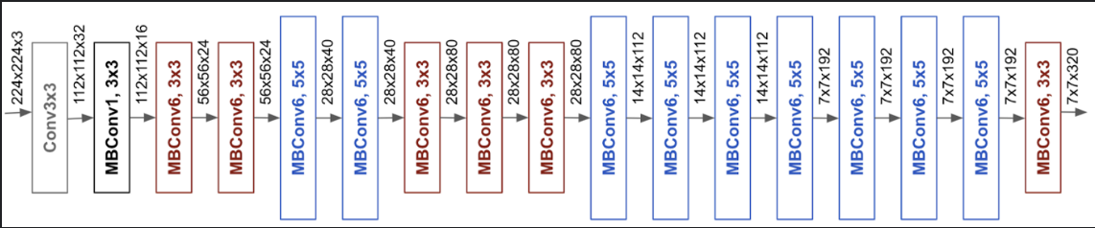

**References**

1. Fayyaz, A. M., Sharif, M., Azam, S., Karim, A., & El-Den, J. (2023). Analysis of Diabetic Retinopathy (DR) based on the deep learning. Information, 14(1), 30. https://doi.org/10.3390/info14010030
2. Aziz, T., Charoenlarpnopparut, C., & Mahapakulchai, S. (2023). Deep learning-based hemorrhage detection for diabetic retinopathy screening. Scientific Reports, 13(1). https://doi.org/10.1038/s41598-023-28680-3
3. Usman, T. M., Saheed, Y. K., Djitog, I., & Nsang, A. S. (2023). Diabetic retinopathy detection using principal component analysis multi-label feature extraction and classification. International Journal of Cognitive Computing in Engineering, 4, 78–88. https://doi.org/10.1016/j.ijcce.2023.02.002
4. Wan, S., Liang, Y., & Zhang, Y. (2018). Deep convolutional neural networks for diabetic retinopathy detection by image classification. Computers & Electrical Engineering, 72, 274–282. https://doi.org/10.1016/j.compeleceng.2018.07.042

**Thank You**

We would like to extend our heartfelt gratitude to all those who contributed to the success of this project. Your support, guidance, and collaboration have been invaluable throughout this journey.

**Acknowledgments**

***Project Supervisor:*** - Dr.Gopal Singh Tandel your expert guidance and mentor-ship were instrumental in shaping the project's direction and ensuring its successful completion.

Team Members: Prasannajeet Ojha (22BHI10187),Tanmay Srivastav(22BHI10127), Navanil Das (22BHI10138), Aditya Narayan Jha(22BHI10082), Isha Naik(22BHI10124). Each of you played a crucial role in bringing this project to fruition. Your dedication and hard work are greatly appreciated.

***Reviewers of the Project :*** We would like to express our sincere gratitude to the reviewers Dr.Swagat Kumar Samantaray, Dr. Raghvendra Mishra and Dr.Jyothi Chouhan who dedicated their time and expertise to evaluate and provide feedback on our project. Your valuable insights and constructive comments have significantly contributed to the project's quality and improvement.

***Colleagues and Peers:*** Our sincere thanks to colleagues and peers who shared their expertise, insights, and feedback, enriching the project with diverse perspectives.

***Institutions and Laboratories:*** We are grateful to VIT Bhopal University for granting us access to facilities, equipment, and resources critical for the project's success.

***Family and Friends:*** To our family and friends, your unwavering encouragement and understanding sustained us during the project's challenges.

***Conclusion***

Your collective support has been instrumental in achieving our project's goals. We thank you for being part of this journey, and your contributions will forever be remembered.

Sincerely,

Prasannajeet Ojha (22BHI10187)

Tanmay Srivastav (22BHI10127)

Aditya Narayan Jha (22BHI10082)

Navanil Das (22BHI10138)

Isha Choudhary (22BHI10124)